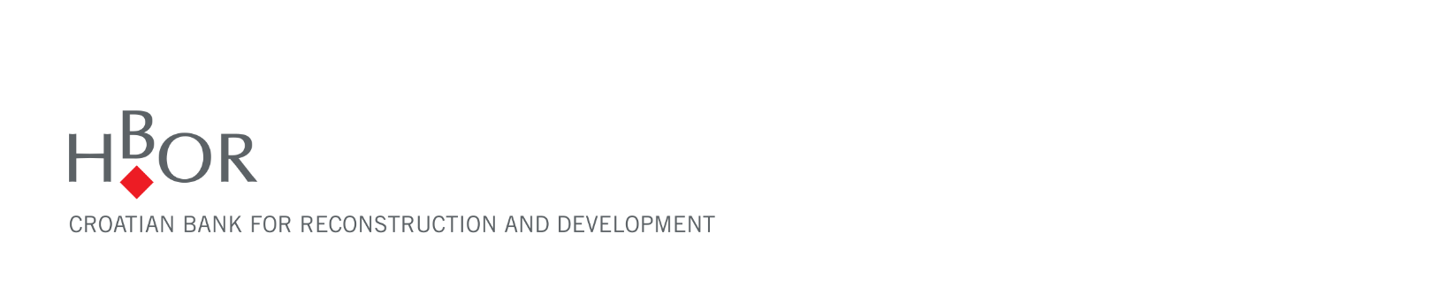

**SEMI-ANNUAL REPORT**

**FOR THE PERIOD 1 JANUARY – 30 JUNE 2025**

**Zagreb, August 2025**



**STATEMENT OF PERSONS RESPONSIBLE FOR THE PREPARATION OF SEMI-ANNUAL REPORT**

To the best of our knowledge the management report for the period 1 January – 30 June 2025 contains a truthful development of events and business results as well as the position of the Croatian Bank for Reconstruction and Development and the Group, and the description of the most significant risks and contingencies the Croatian Bank for Reconstruction and Development and the Group are exposed to.

|  |  |  |
| --- | --- | --- |
| President of the Management Board | Member of the Management Board | Member of the Management Board |
|  |  |  |
| Hrvoje Čuvalo, MSc | Alan Herjavec, MSc | Josip Pavković |

Zagreb, 21 August 2025

**MANAGEMENT REPORT FOR THE PERIOD**

**1 JANUARY – 30 JUNE 2025**

**RESULTS OF THE GROUP**

**BREAKDOWN OF THE MOST SIGNIFICANT FINANCIAL INFORMATION OF hbor GROUP**

|  |  |  |  |
| --- | --- | --- | --- |
| -in millions of euros- | **2023** | **2024** | **30 June 2025** |
| **Total assets** | 4,021.5 | 3,999.7 | 3,985.6 |
| **Gross loans** | 4,077.6 | 4,013.4 | 3,930.7 |
| **Total equity** | 1,457.9 | 1,504.3 | 1,560.4 |
|  | **1 January – 30 June 2023** | **1 January – 30 June 2024** | **1 January – 30 June 2025** |
| **Total income** | 58.4 | 76.5 | 102.9 |
| **Total expense** | (28.6) | (38.0) | (48.0) |
| **Profit** | 29.8 | 38.5 | 54.9 |
| **Interest income calculated on the basis of effective interest rate method and income from cancellation of the subsidy deferral at the expense of HBOR’s operations** | 44.3 | 56.3 | 58.7 |
| **Interest expense** | (12.3) | (22.1) | (24.2) |
| **Net interest income** | 32.0 | 34.2 | 34.5 |

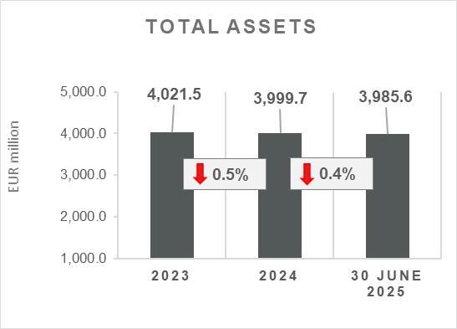 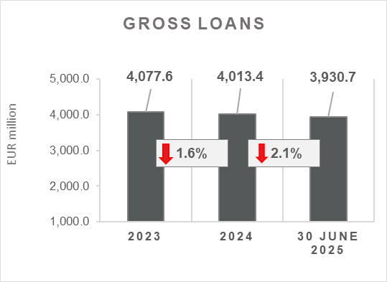

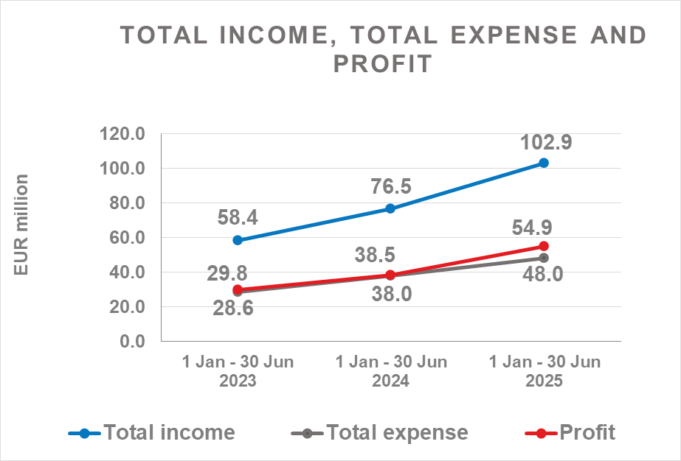 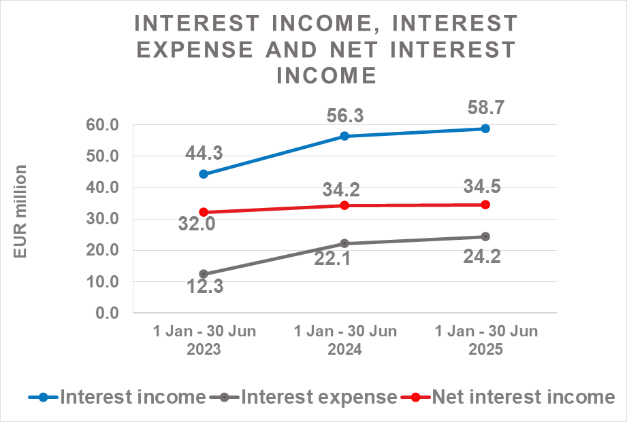

**Results of the Group**

In the period 1 January – 30 June 2025, the HBOR Group generated profit after tax in the amount of EUR 54.9 million.

Pursuant to the provisions of the Act on HBOR, the parent company is exempt from income tax and income tax liabilities arise exclusively from the activities of the other members of the Group.

In the period 1 January – 30 June 2025, total income on consolidated basis amounted to EUR 102.9 million, whereas total expenses amounted to EUR 48.0 million.

The consolidated total income increased by 34.5 percent, whereas total expenses increased by 26.3 percent compared to the same period previous year due to the developments in total income and expenses of the parent company.

In the structure of income of the Group, the largest portion, i.e. 57.0 percent, relates to interest income as a result of operations of the parent company.

The major part of total expenses, relates to interest expense, i.e. 50.4 percent, arising from the operations of the parent company.

The consolidated operating expenses in the period 1 January – 30 June 2025 amounted to EUR 17.5 million and consisted of general and administrative expenses and other operating expenses.

On 30 June 2025, the Group had 471 employees (on 30 June 2024: 447 employees).

**Assets and liabilities of the Group**

Total assets of the Group on consolidated basis amount to EUR 3,985.6 million and were retained at the level from the beginning of the year.

In the structure of assets, the major portion relates to the lending activities of the parent company, i.e. net loans account for 87.2 percent of total assets.

Total liabilities and total equity as at 30 June 2025 amount to EUR 3,985.6 million, of which amount total liabilities equal EUR 2,425.2 million, i.e. 60.8 percent.

In total liabilities and total equity of the Group, the major portion, i.e. 57.1 percent, consists of borrowings of the parent company.

At the end of the reporting period, total equity on consolidated basis amounted to EUR 1,560.4 million and accounted for 39.2 percent of total liabilities and total equity of the Group.

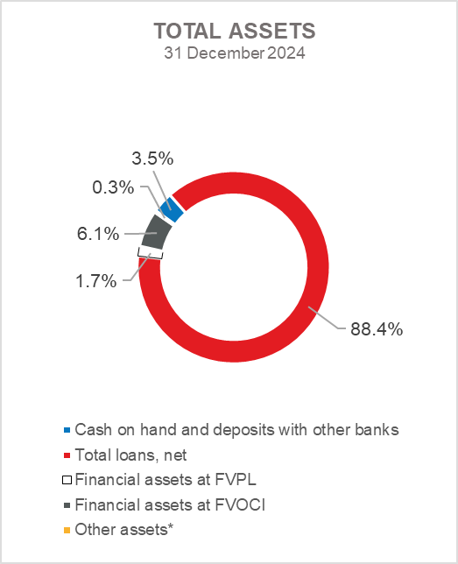 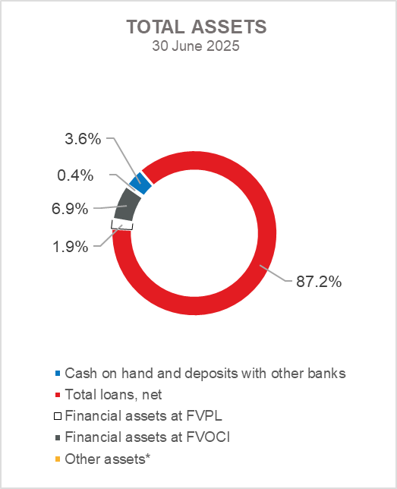

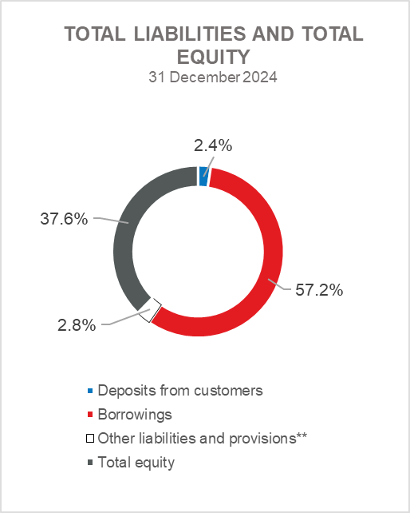  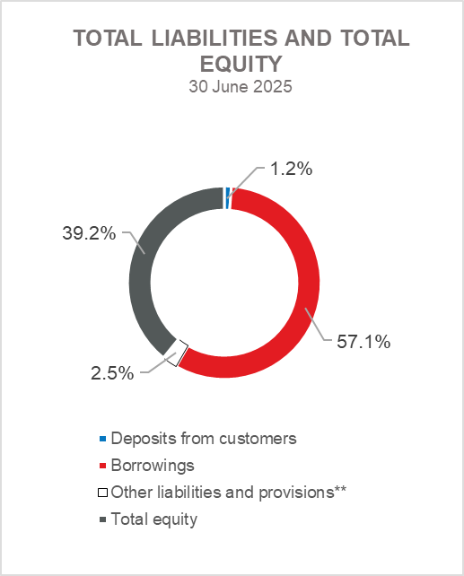

*Property, plant and equipment and intangible assets, Foreclosed assets and Other assets.

**Provisioning includes provisioning for guarantees, commitments and other liabilities.

**RESULTS OF HBOR**

**OVERVIEW OF FINANCIAL PERFORMANCE OF HBOR**

The following text gives an overview and explanation of the significant changes in financial position and operating performance in the reporting period.

**Financial performance**

In the period from 1 January to 30 June 2025, HBOR generated total income of EUR 101.5 million, expenses of EUR 46.6 million and profit in the amount of EUR 54.9 million. HBOR’s profit generated in the reporting period increased by EUR 16.5 million compared with the profit generated in the same period last year.

The increase in profit in the period from 1 January to 30 June 2025 compared with the same period last year is a result of an increase in total income by EUR 26.5 million and an increase in total expenses by EUR 10.0 million.

The circumstances that affected the financial result achieved in the six-month reporting period 2025 compared to the results generated in the same period in 2024 are:

* increase in interest income of EUR 2.1 million,
* increase income from the cancellation of the subsidy deferral at the expense of HBOR's operations by EUR 0.3 million,
* increase in interest expenses of EUR 2.1 million,
* increase in net income from fees and commissions of EUR 0.1 million,
* increase in net gains from financial activities in the amount of EUR 4.7 million,
* decrease in other income of EUR 0.7 million,
* increase in impairment gain and provisions by EUR 20.0 million,
* increase in operating expenses of EUR 2.2 million,
* increase in subsidy cost at the expense of HBOR’s operations by EUR 5.7 million.

A detailed description of trends is given for each category separately in the following text.

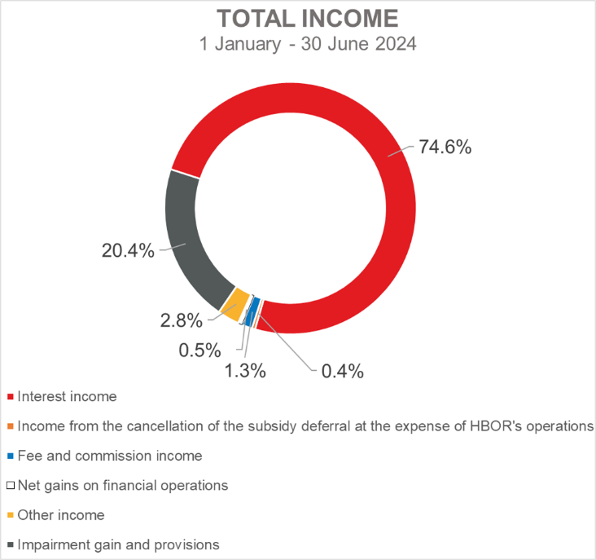 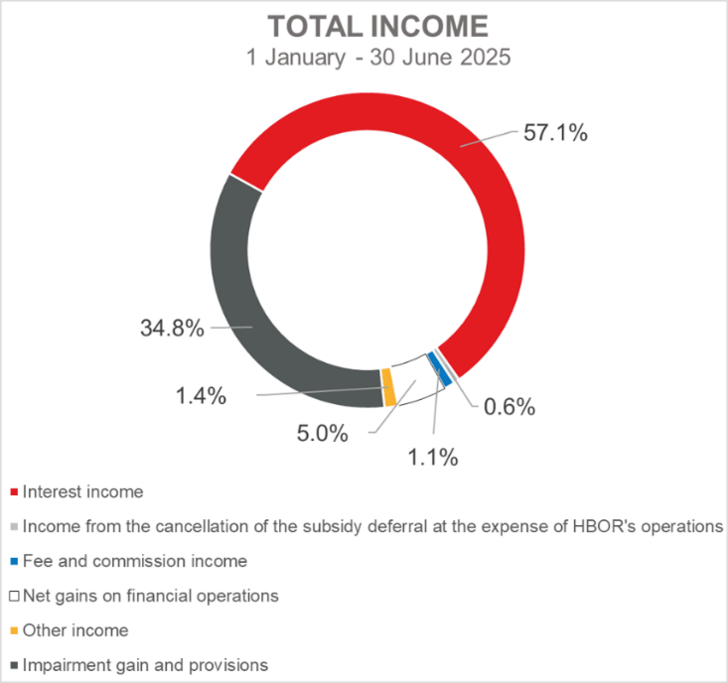

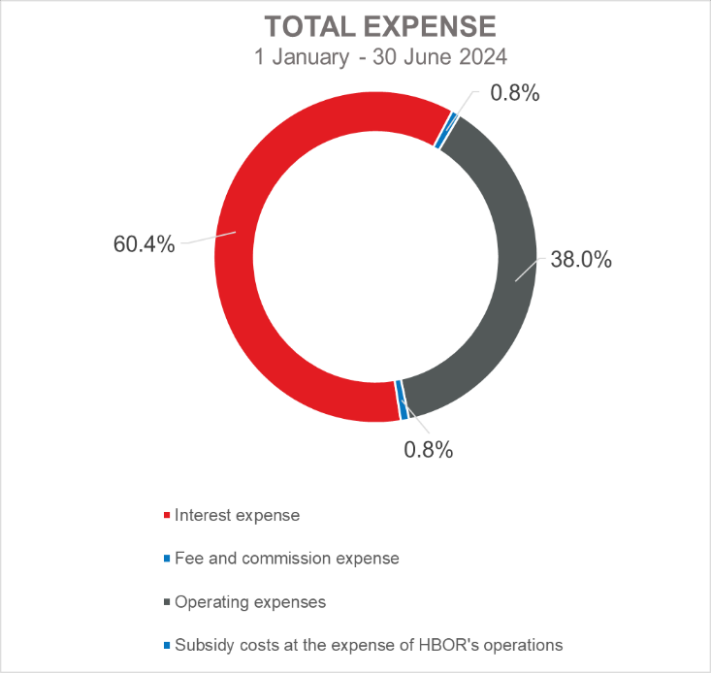 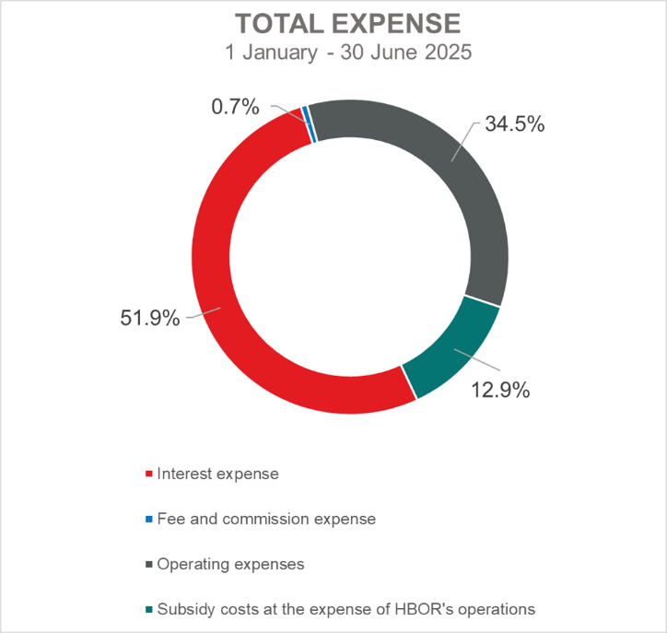

***Net interest income***

Net interest income amounted to EUR 34.4 million, an increase of 0.9 percent on the same period of the previous year.

Interest income stood at EUR 58.0 million, an increase of 3.8 percent compared with the same reporting period previous year. The increase in interest income is largely the result of the increase in the effective interest rate.

In addition, interest income rose by EUR 0.3 million owing to the income resulting from the cancellation of the subsidy deferral at the expense of HBOR's operations.

Interest expenses amounted to EUR 24.2 million, an increase of 9.5 percent on the same reporting period last year, which is mostly due to an increase in interest rates on borrowings.

Considering the described trends, the higher increase in interest income in the absolute amount of EUR 2.4 million compared with interest expenses of EUR 2.1 million influenced the increase in the net interest margin in comparison with the same reporting period previous year, which stood at 1.70 percent, whereas it had amounted to 1.68 percent in the same period previous year.

***Net fee income and commission income***

Net fee and commission income amounted to EUR 0.8 million, an increase of 14.3 percent compared with the same reporting period last year due to an increase in income from fees for issued guarantees.

***Net gains/(losses) on financial operations***

Net gains/(losses) on financial operations are comprised of net foreign exchange gains/(losses) on the principal amount of receivables and liabilities, gains/(losses) arising out of value adjustment of financial assets stated at fair value through profit or loss and realised gains/(losses) arising out of financial assets at fair value through other comprehensive income.

In the reporting period, net gains from financial activities amounted to EUR 5.1 million, whereas, in the same reporting period previous year, net gains amounted to EUR 0.4 million.

.

A breakdown of changes in the exchange rate of the euros against the USD:

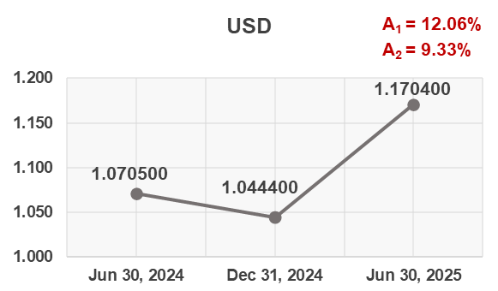

Note:

A1 = EUR appreciation Jun 30, 2025/Dec 31, 2024

A2 = EUR appreciation Jun 30, 2025/Jun 30, 2024

Funds and sources of funds that are denominated in another currency or are indexed to the currency clause are converted by HBOR into the equivalent value in EUR at the middle exchange rate of HBOR or another agreed exchange rate on the reporting date.

Revenues and expenditures in another currency are converted at the exchange rate on the transaction date. The resulting foreign exchange gains or losses are recorded in the Profit or Loss Account in net figures.

***Operating expenses***

Operating expenses that include general and administrative expenses and other operating expenses stood at EUR 16.1 million, an increase of 15.8 percent compared with the same reporting period last year, mostly as a result of an increase in administrative expenses.

On 30 June 2025, HBOR had 449 employees (on 30 June 2024: 427 employees).

***Subsidy costs at the expense of HBOR's operations***

Subsidy costs at the expense of HBOR's operations stood at HRK 6.0 million and are linked with the new product of subsidising interest rates at the expense of HBOR's operations that was introduced in the second half of 2023.

***Impairment gain/(loss) and provisions***

In the reporting period, a net gain from impairment of placements in the amount of EUR 35.3 million was recorded (in the period 1 January – 30 June 2024: net gain in the amount of EUR 15.3 million).

The text to follow contains a breakdown of portfolio quality:

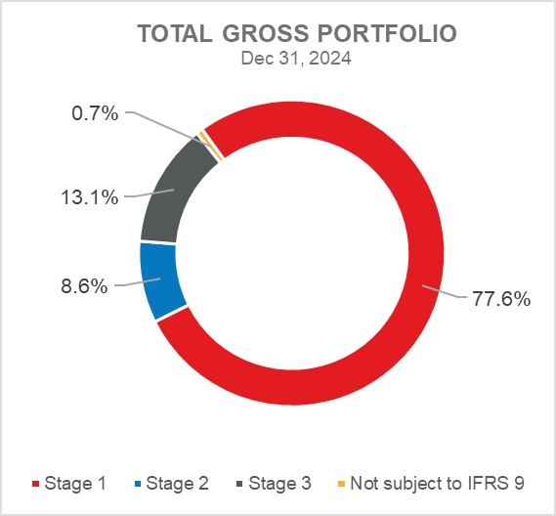 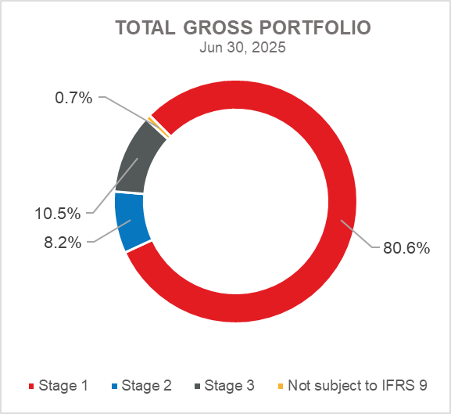

**Overview of total gross portfolio and provisions by structure – financial institutions and direct**

|  |  |  |  |  |
| --- | --- | --- | --- | --- |
|  | **2024** | | **Jun 30, 2025** | |
|  | **In millions of euros** | **Breakdown**  **(percent)** | **In millions of euros** | **Breakdown**  **(percent)** |
| **Total gross portfolio** | **4,992.7** | **100.0** | **4,975.4** | **100.0** |
| **Of which:** |  |  |  |  |
| **- financial institutions** | 1,580.8 | 31.7 | 1,630.1 | 32.8 |
| **- direct** | 3,411.9 | 68.3 | 3,345.3 | 67.2 |
| **Total provisions** | **496.7** | **100.0** | **472.5** | **100.0** |
| **Of which:** |  |  |  |  |
| **- financial institutions** | 8.2 | 1.7 | 9.1 | 1.9 |
| **- direct** | 488.5 | 98.3 | 463.4 | 98.1 |
| **Provisions/gross portfolio** | **9.9 percent** | **-** | **9.5 percent** | **-** |

.

**Significant changes in financial position**

Total assets of HBOR as at 30 June 2025 amounted to EUR 3,981.9 million and were retained at the level from the beginning of the year.

***Cash on hand and deposits with other banks***

As at 30 June 2025, cash on hand and deposits with other banks amounted to EUR 142.2 million representing 3.6 percent of total assets, an increase of 4.6 percent compared with 31 December 2024 as a result of reallocation of liquidity reserve funds.

***Loans to financial institutions and other customers***

As at 30 June 2025, total net loans amounted to EUR 3,477.0 million representing 87.3 percent of total assets, a decrease 1.6 percent on the beginning of the year.

Total gross loans amounted to EUR 3,930.7 million, a decrease 2.1 percent on the beginning of the year. Gross loans to other customers decreased by 5 percent on the beginning of the year. Gross loans to financial institutions increased by 4.5 percent on the beginning of the year.

As at 30 June 2025, the proportion between gross loans on-lent through financial institutions and direct placements stood at 33 percent : 67 percent (31 December 2024: 31 percent: 69 percent).

***Financial assets at fair value through profit or loss***

Loans at fair value (HBOR has determined that mezzanine loans are classified here), investments in investment funds and a part of equity instruments are classified to these assets. As at 30 June 2025, the total amount of these assets was EUR 74.4 million representing 1.9 percent of total assets.

***Financial assets at fair value through other comprehensive income***

***a) Debt instruments***

Bonds of the Republic of Croatia and treasury bills of the Ministry of Finance as part of liquidity reserve as well as bonds of a company are classified to these assets. On the reporting date, they amounted to EUR 258.9 million, representing 5.9 percent of total assets and recorded an increase compared to the beginning of the year by 6.5 percent.

The impairment of these financial assets is calculated through the application of the model of expected credit losses in the manner that provisions are recognised in the accounts of other comprehensive income, thus not reducing the carrying amount of these financial assets in the statement on financial position. On the reporting date, they amounted to EUR 0.4 million in other reserves.

***b) Equity instruments***

Equity instruments (shares of companies) that HBOR does not intend to sell and to which irrevocable option of subsequent measurement of fair value through other comprehensive income without recycling is applied are classified to these assets, i.e. reserves recognised under other comprehensive income will never be transferred to the statement on profit or loss.

On the reporting date, these assets amounted to EUR 8.5 million, representing 0.2 percent of total assets.

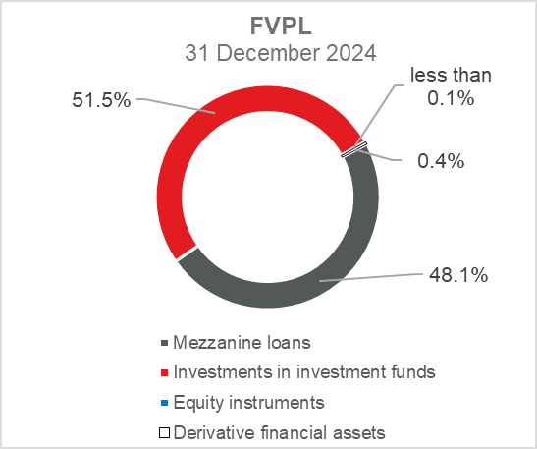 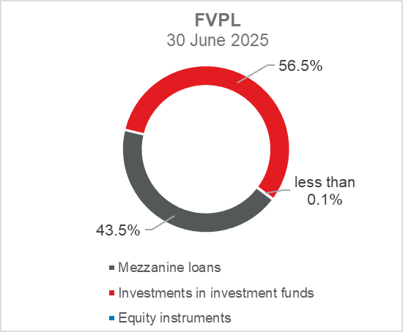

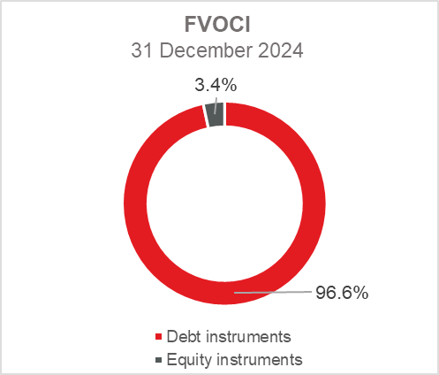 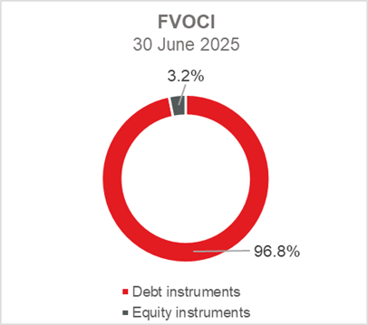

***Total liabilities***

As at 30 June 2025, total liabilities amounted to EUR 2,422.3 million, which represents 60.8 percent of total liabilities and total equity. The major part of total liabilities consists of HBOR’s borrowings in the total amount of EUR 2,277.4 million.

Borrowings decreased by 0.5 percent compared with the beginning of the year, whereas changes in these liabilities are shown in the following table:

|  |  |
| --- | --- |
|  | (in millions of euros) |
| - Draw-down of funds borrowed | 295.0 |
| - Repayments of borrowings | (302.9) |
| - Foreign exchange gains or losses | (1.9) |
| - Other calculations * | (1.1) |
| **Total changes** | **(10.9)** |
|  |  |
| *\* Other calculations relate to changes in amount of interest not due and deferred fees.* | |

During 2025, HBOR continued to raise funds, and in the second quarter of 2025, it signed a loan agreement with the Council of Europe Development Bank (CEB) for financing micro, small and medium-sized enterprises, urban, rural and regional development, as well as social and affordable housing projects in the Republic of Croatia in the amount of EUR 250 million.

After the reporting period, at the beginning of the third quarter, HBOR signed a Finance Contract in the amount of EUR 150 million with the European Investment Bank (EIB) for financing Mid-Caps, the public sector and large private companies. Special emphasis of this loan will be put on promoting green investments, and it is the first tranche of a new financing accord between the two institutions, with a total value of EUR 350 million.

***Total equity***

Out of the total amount of total liabilities and total equity, EUR 1,559.6 million or 39.2 percent relate to total equity.

Total equity of HBOR is comprised of the capital and the guarantee fund. HBOR’s capital is comprised of founder’s capital contributed from the budget of the Republic of Croatia, retained earnings from the profits generated in the previous years, other reserves and profits for the current period.

The total amount of capital contributed from the budget of the Republic of Croatia stood at EUR 905.3 million, and the remaining amount to be contributed to the founder’s capital up to the total amount of EUR 929.1 million set by the HBOR Act is EUR 23.8 million.

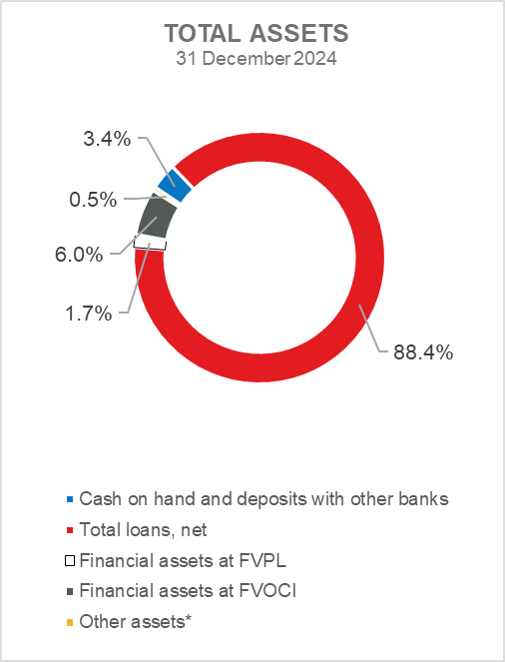 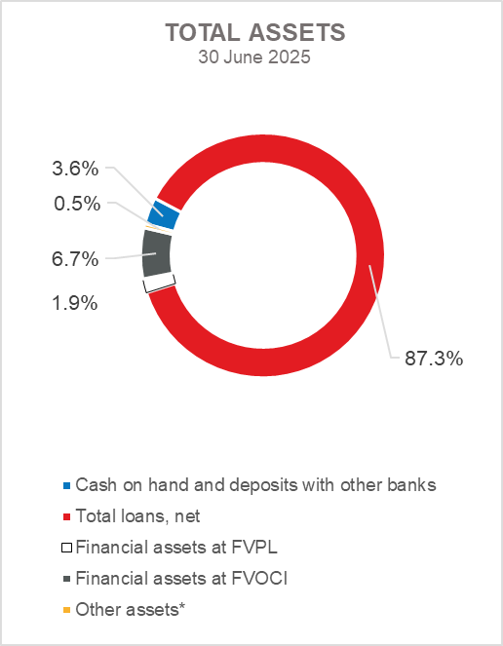

Slika na kojoj se prikazuje tekst, snimka zaslona, Font, krug

Sadržaj generiran umjetnom inteligencijom može biti netočan. 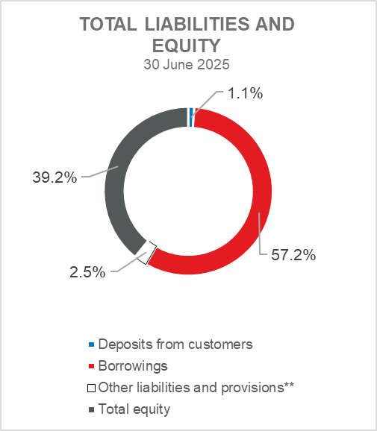

*Investments in subsidiaries, Property, plant and equipment and intangible assets, Foreclosed assets and Other assets.

** Provisioning includes provisioning for guarantees, commitments and other liabilities.